**Fatima First Saturday Devotion to the Immaculate Heart of Mary.**

*Insert the name of the church and location here*

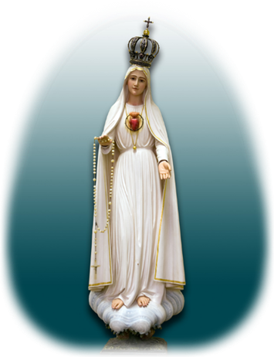In 1917, in Cova da Iria, Fátima, Portugal, the Blessed Virgin Mary “a Lady more brilliant than the Sun”, showed Herself seven times to three shepherd children – Lúcia dos Santos, Francisco and Jacinta Marto.

The message given by the Blessed Virgin Mary in Fatima summed up as a passionate appeal for the world’s conversion through devotion to Her Immaculate Heart. This devotion was to be manifested in the Communion of Reparation of First Saturdays.

On December 10, 1925, the Virgin Mary appeared to Sister Lucia (Lúcia Santos, one of the visionaries of Our Lady of Fátima) at the convent in Pontevedra, Spain, and by Her side, elevated on a luminous cloud, was the Child Jesus. According to Lucia, Mary requested again the institution of the Devotion of the First Saturdays in reparation to Her Immaculate Heart. Then She promised to assist at the hour of death with the grace necessary for salvation all who, with the intention of making reparation to Her, will practice the following devotion on the first Saturday of five consecutive months.

**To practice the First Saturday Devotions:**

1. Go to the Sacrament of Confession: This can be done up to eight days prior to First Saturday (provided that no mortal sin is committed between), however, the intention of reparation to the Immaculate Heart must be in one’s mind and heart prior and during confession.

2. Attend Holy Mass on the First Saturday of the month.

3. Receive Holy Communion, offering up the benefits thereof in reparation for offenses against the Immaculate Heart.

4. Recite five decades of the Holy Rosary, including the Fatima prayer after each decade.

5. Keep Our Lady company for fifteen minutes, while meditating with Her on the mysteries of the Rosary.

**Devotion starts at:**

*Insert the expected timeline here after consulting with your local pastor. For example:*

*7:40 AM - Exposition of the Blessed Sacrament*

*7:50 AM - Rosary*

*8:10 AM - 8:25 AM - Meditation on the Mysteries*

*Confessions*

*8:45 AM - Benediction*

*9:00 AM - Holy Mass.*